|  |  |  |
| --- | --- | --- |
| ***35*** | ***16/09/21*** | ***Implement 1D array using dynamic memory allocation*** |

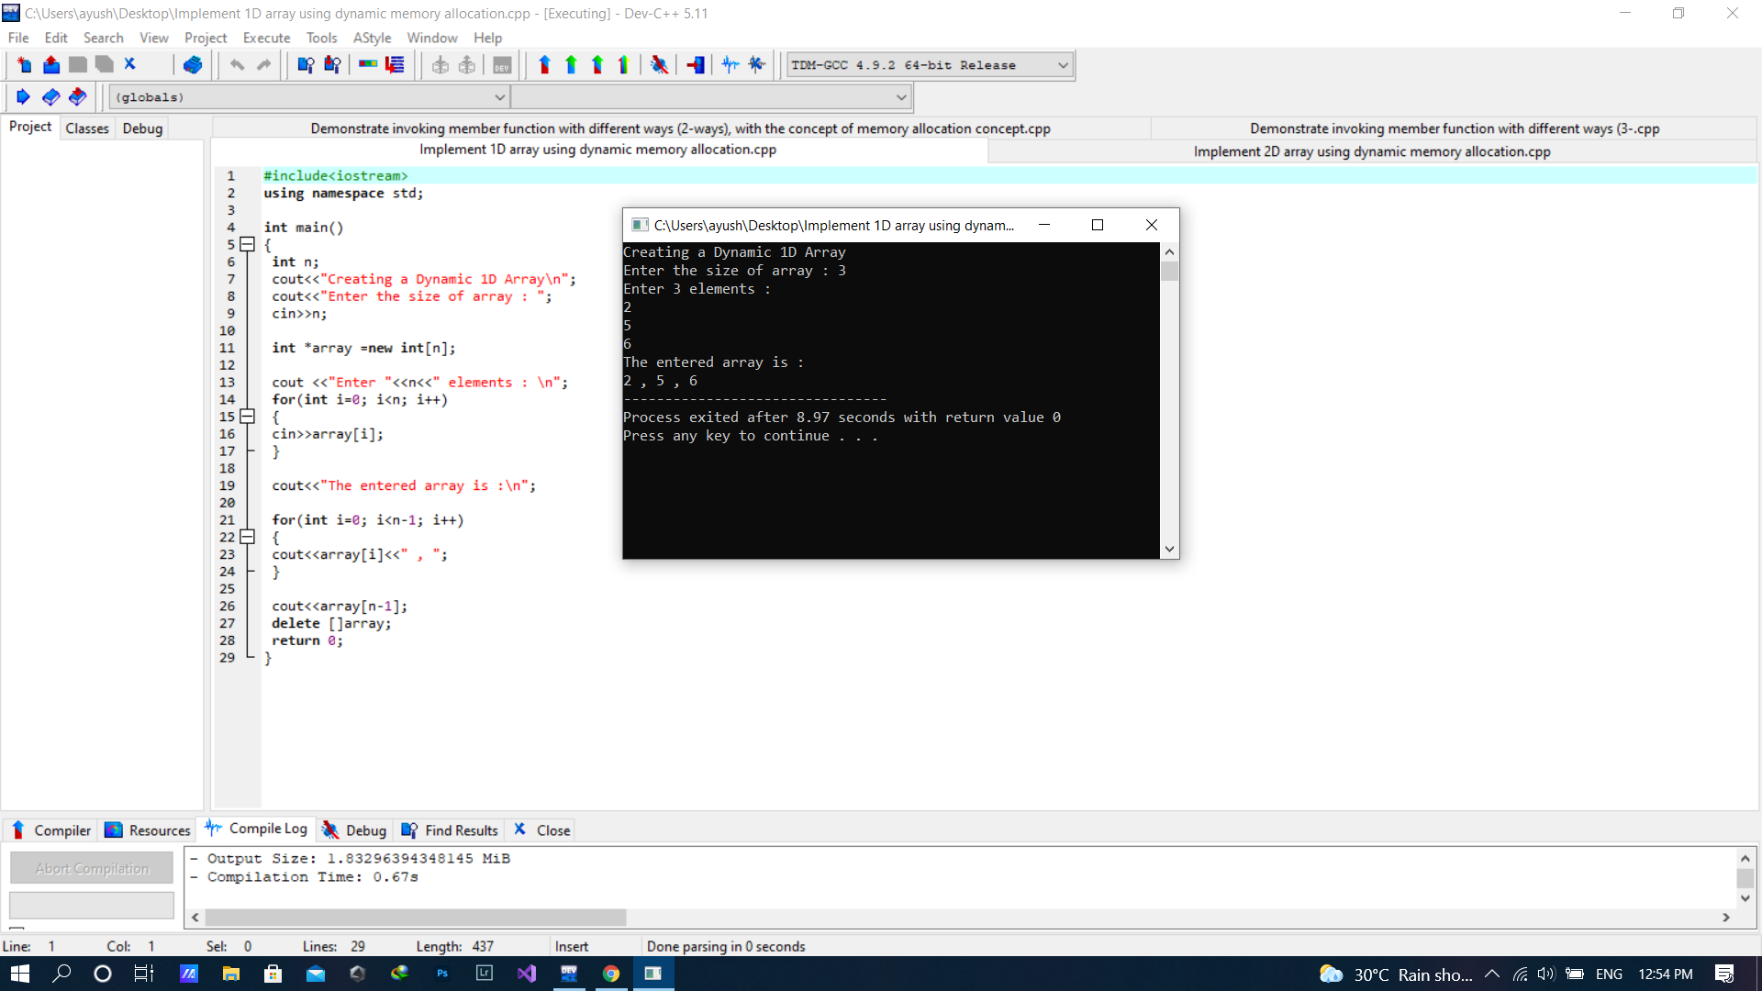

|  |  |  |
| --- | --- | --- |
| ***36*** | ***16/09/21*** | ***Implement 2D array using dynamic memory allocation*** |

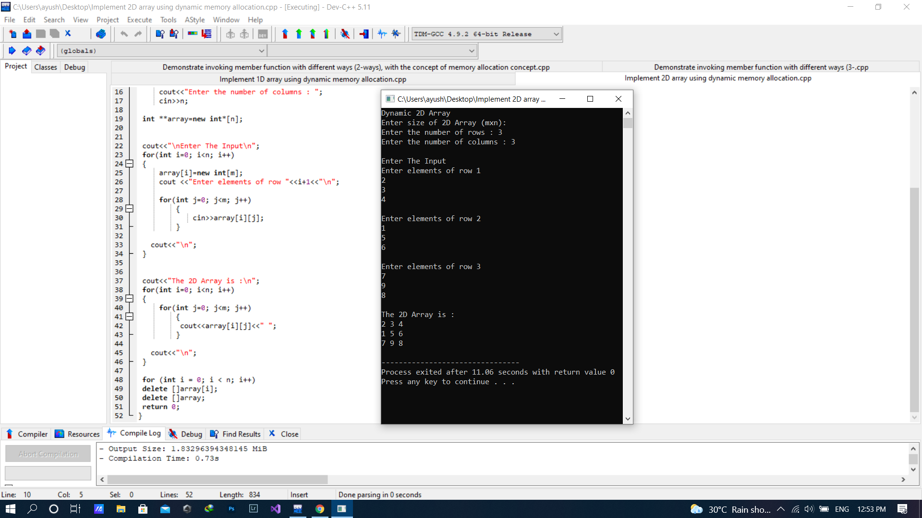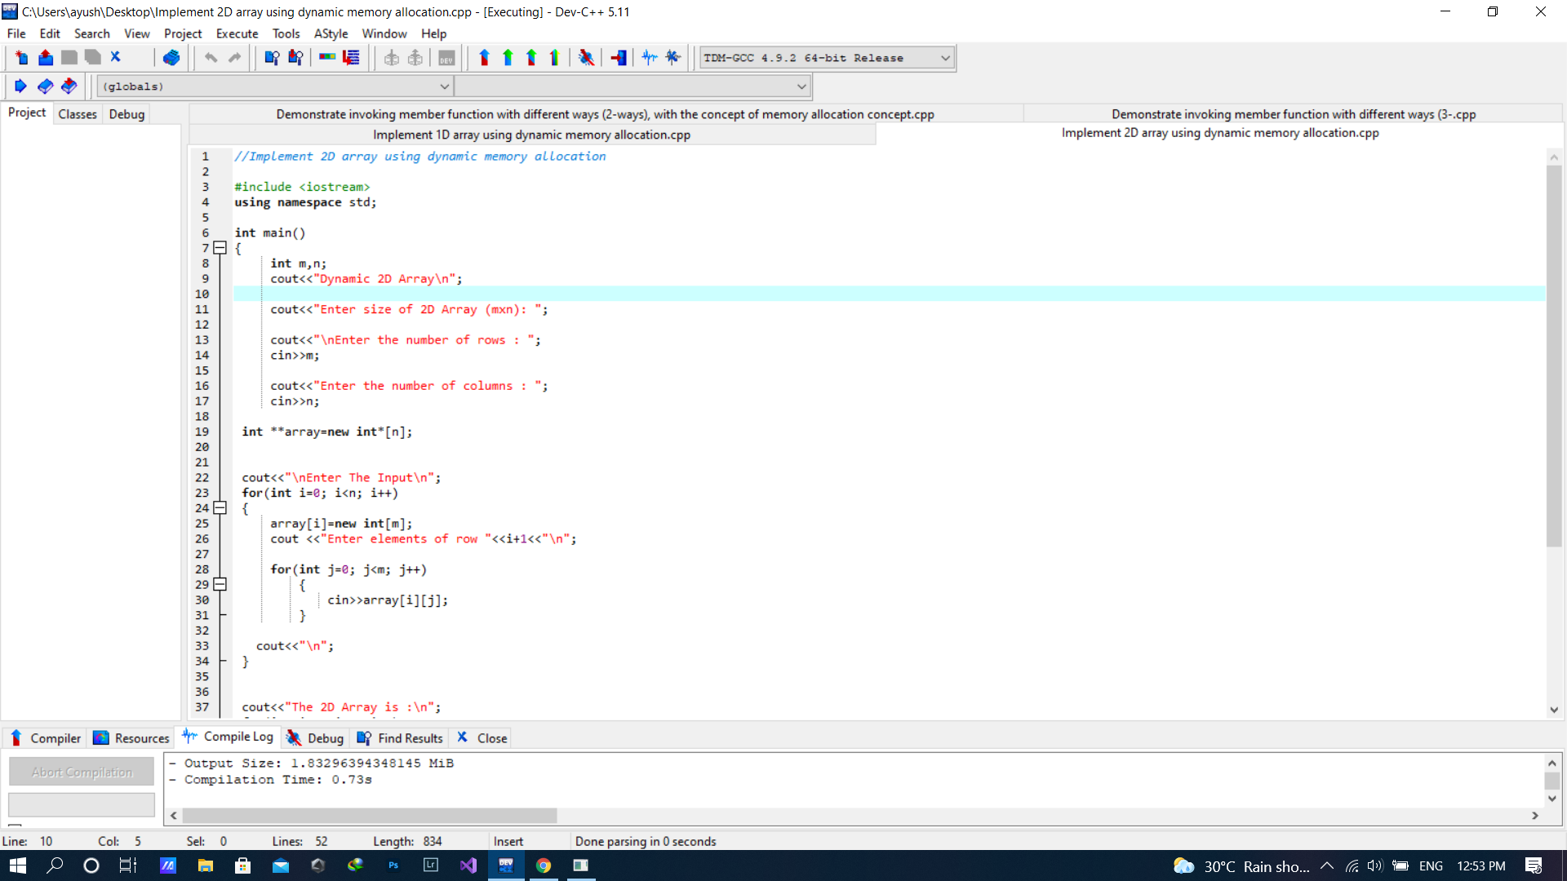

|  |  |  |
| --- | --- | --- |
| ***37*** | ***16/09/21*** | ***Demonstrate invoking member function with different ways (3-ways), but no dynamic memory allocation being used*** |

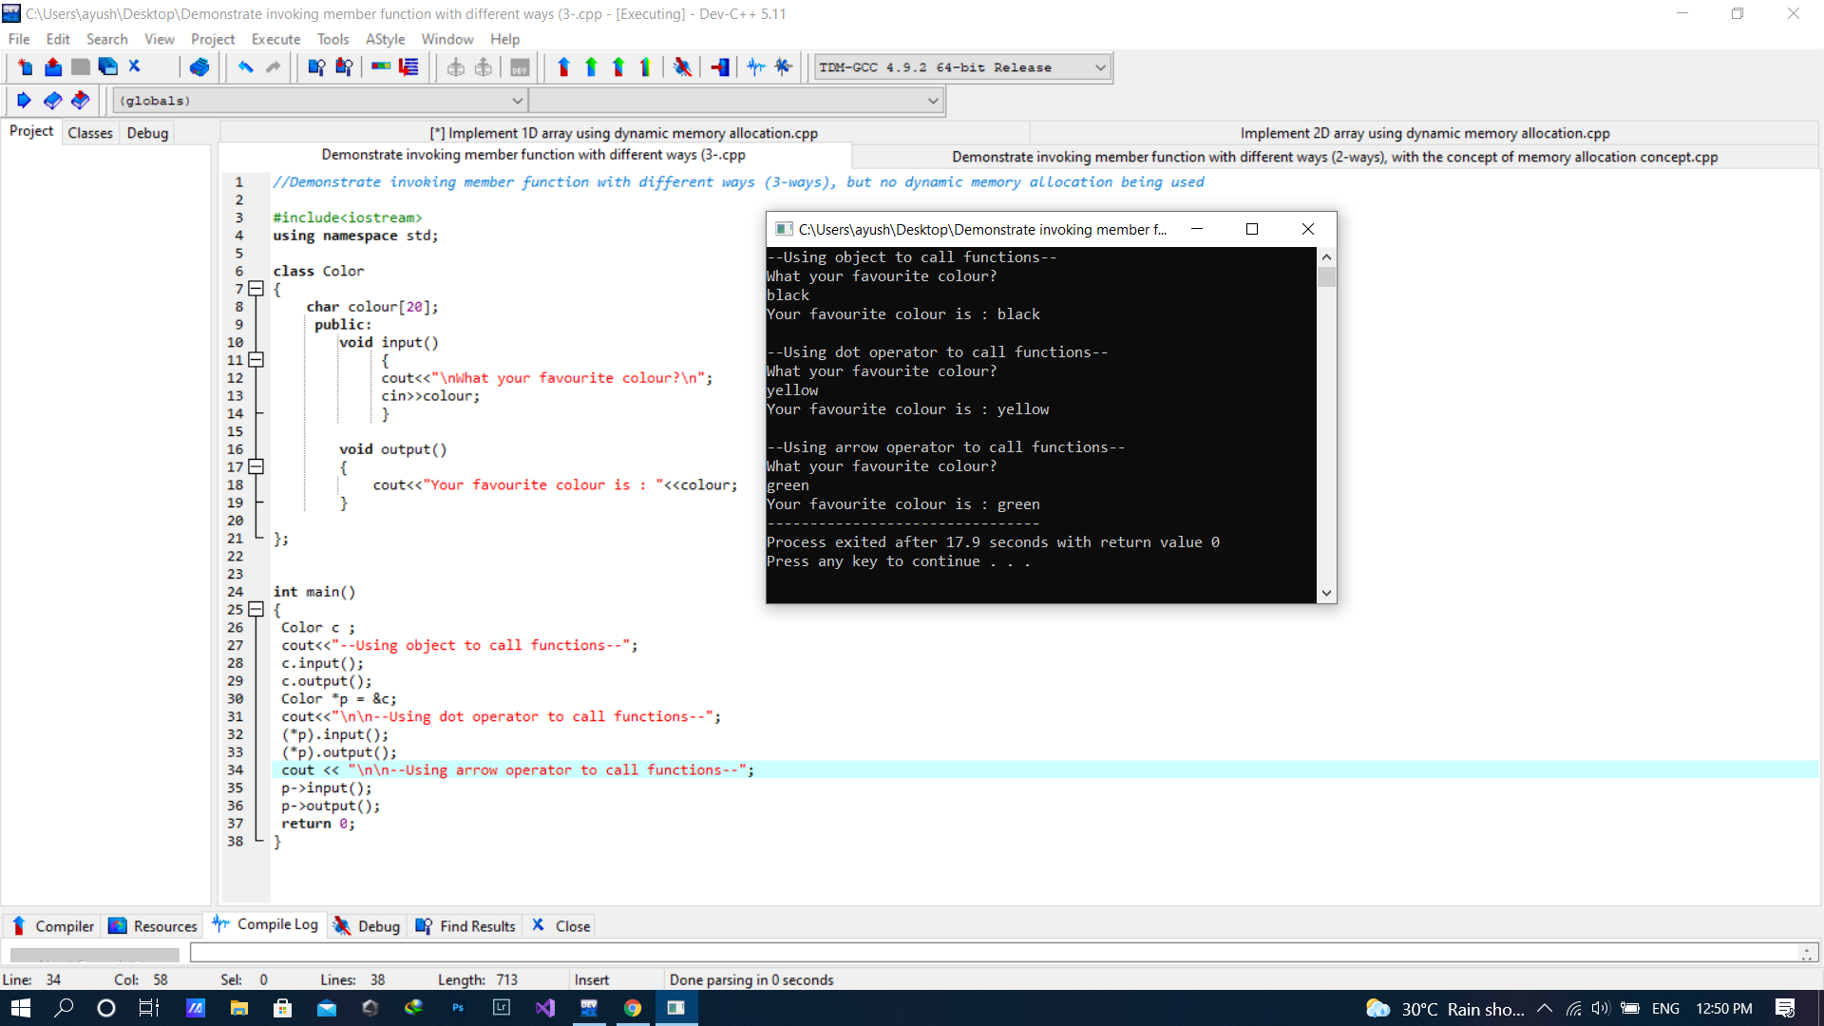

|  |  |  |
| --- | --- | --- |
| ***38*** | ***16/09/21*** | ***Demonstrate invoking member function with different ways (2-ways), with the concept of memory allocation concept*** |

